MS (CHIMEI)

The MS Resin ACRYSTEX® of Chimei is a transparent copolymerization primarily composed of methyl methacrylate (MMA) and styrene monomer (SM). Its advantages include excellent transparency, optical properties, low hygroscopicity, good weather resistance, ease of processing, low residual stress for molded products, etc. The proportion of MS Resin is lower compared to that of Acrylic, and the cost is also cheaper.

[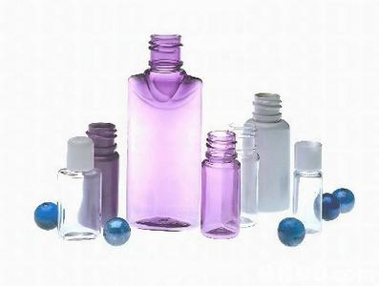](http://image.baidu.com/i?ct=503316480&z=&tn=baiduimagedetail&ipn=d&word=MS%E5%A1%91%E6%96%99&step_word=&ie=utf-8&in=25221&cl=2&lm=-1&st=-1&pn=124&rn=1&di=123970095370&ln=1985&fr=&&fmq=1392358051299_R&ic=0&s=&se=1&sme=0&tab=&width=&height=&face=0&is=&istype=2&ist=&jit=&objurl=http%3A%2F%2Fhk.media2.88db.com%2FDB88UploadFiles%2F2009%2F02%2F23%2F995B5489-711A-494C-8224-6710F5F9A20F.jpg)